**Fast and Safe Reopening’s and Recovery Using Open Data, Project Management and Compliance to Standards**

John M. Aaron

06/06/2020

The COVID-19 pandemic has created a disastrous situation in our country without precedent-at least for our current generation of citizens and leaders. The lack of historical precedent has put our state governors and local mayors into unchartered waters causing them to scramble in search for a rational way out of the crisis and a fast, but safe return to normalcy. An optimized solution can be found in basic economic principles, project management, and statistical testing tied to demonstrated compliance to standards. This webinar, featuring an expert panel, will explore how these core concepts can be implemented tactically and efficiently at the local level to secure immediate safety, inform consumer and employee confidence and sustain long-term economic prosperity.

Safety and economic prosperity intersect. Following Preston’s 1975 modeling approach as applied to available 2017 OECD data (refer to figure on left panel below), we see that countries with lower per capita GDP in dollars have lower life expectancies at birth. Although correlation does not prove causation, we can say that with some probability *p* > 0 a structural decline in economic prosperity will eventually lead to lower average life expectancies. And life expectancy is the ultimate measure of safety for a society.

The figure on the right panel below illustrates the relationship between employment rate and per capita GDP. Here we find that countries with higher employment rates tend to have higher levels of per capita GDP, and conversely countries with lower employment levels tend to have lower per capita GDP.

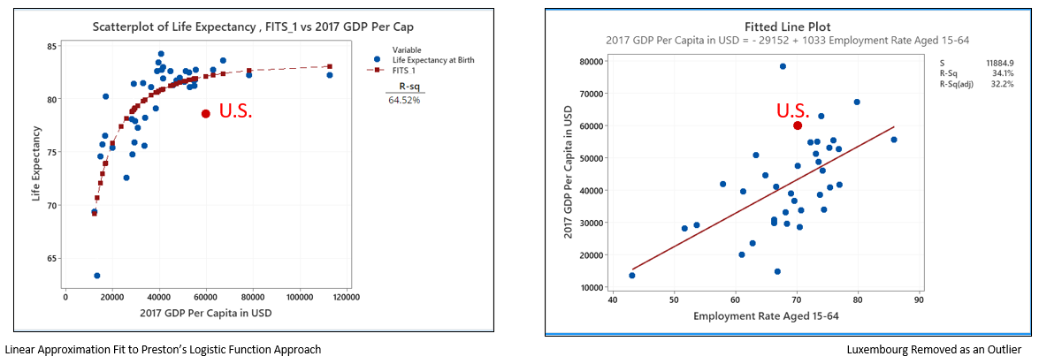

The above analysis gives an economic framework for the policy maker to observe that safety is a multi-dimensional problem. The most immediate form of safety has been, of course, virus avoidance which has resulted in a policy of lockdown of business and residents. But the longer-term dimension of safety is tied to economics, i.e. employment resulting in GDP. So, the dilemma for federal and state policy makers has been to weigh the apparent trade-offs between the short-term and long-term dimensions and to craft a risk adjusted, phased approach toward re-opening and recovery. The question becomes how to accomplish this most efficiently and effectively. Here is where decentralization, open data, statistical testing, and project management enter the equation.

Decentralized execution is a critical component of implementation. States (Massachusetts as an example) are working very hard to implement the CDC guidelines by setting up Covid-19 command centers for the states. These command centers gather state-wide data, provide guidance to citizens, and support a phased approach to re-opening. The problem, however, with centralized command and control is that central planners never have the timely, detailed data or knowledge of specific risks (or lack thereof) needed by individual residents and local businesses. This concept of economic decentralization is the fundamental underpinning of the *Austrian* school of economics often associated with economists Hayek and Von Mises. If alive today their argument would likely be *“let the federal and state authorities give the guidelines and supply available information, but let the local communities acting out of their own self-interest and detailed knowledge handle the tactical execution and decision making at the local level”.*

Going beyond economic theory, evidence for successful use of decentralization can be found in practice. For instance, in recent decades the military has adopted *command concepts* that focus on the importance of communicating the leader’s intent and allowance for individual decision making as a means toward successful mission achievement in combat. This style is in sharp contrast to the earlier top-down approaches used previously in military command. In sports, Hall of Fame NFL coach, Vince Lombardi, demonstrated the successful use of “freedom within structure” which relieved players of tightly scripted plays and allowed them to use their own judgment to adapt to changing game situations.

By setting a decentralized, data-driven approach as a foundation, this webinar proposes a method of tactical execution whereby each local community optimizes its own re-opening and recovery process by establishing an evidence-based project management structure that utilizes quality gate tools. This structured approach enables each local community to efficiently implement established federal/state guidelines and to continually communicate statistically validated risk levels and mitigation efforts to local businesses and residents.

A quality gate approach is an appropriate methodology for managing high stakes initiatives such as the safe reopening and recovery of local communities and businesses. A quality gate is a collection of completion criteria and sufficiency standards representing the satisfactory execution of a phase of a project. The gates function as a set of *super* milestones that can be used to mark discernable change points of quality progress for the project (i.e. phase transition) when sufficiency has been achieved.

In practice, quality gate project management relies heavily upon the availability of relevant metrics and statistical tests to set sufficiency standards and to assess performance to those standards. This is where federal and state command centers have fallen short in some cases. Published metrics have been too highly aggregated for relevant decision making at the local level. As a result, state command centers have been forced to follow the sub-optimal principle of “insufficient reason” whereby state authorities end up trying to enforce uniform risk mitigation policies across widely varying geographic regions without consideration of differing risk conditions. During the webinar the panel describes a different approach that would treat regional variations of risk as meaningful factors. The suggested approach calls for providing each local area (such as a county or sub region) with a continuous pipeline of timely and relevant local data feeding a data sharing platform. The objective of this sharing technology is enabling the local areas to better inform their communities during times of crisis and to gain timely access to valid data sets to drive decision making at the local level.

In addition to the lack of timely data, the public reporting by federal and some state policy makers has, at times, demonstrated a degree of immaturity in the use of scientific methodology. As Popper (1959) and other scientific philosophers have successfully argued for years, scientific statements must be tested through rigorous attempts at falsification. Yet, over recent months we have observed critical public health and economic decisions based solely on graphical displays that lack a demarcation point for the rejection or acceptance of a null hypothesis. In this webinar the panel addresses this shortcoming and describes several available alternatives.

Full economic recovery requires a return to normal levels of consumer demand. To achieve this outcome businesses must assure the public that their establishments (i.e. restaurants, bars, hotels, sports arenas, etc.) are safe. To address this requirement, the webinar discusses the use of 3rd party testing, inspection, and certification services available to local businesses. As illustrated in the figure below, the targeted effect of these services is to communicate an assurance of safety that instills consumer and employee confidence.

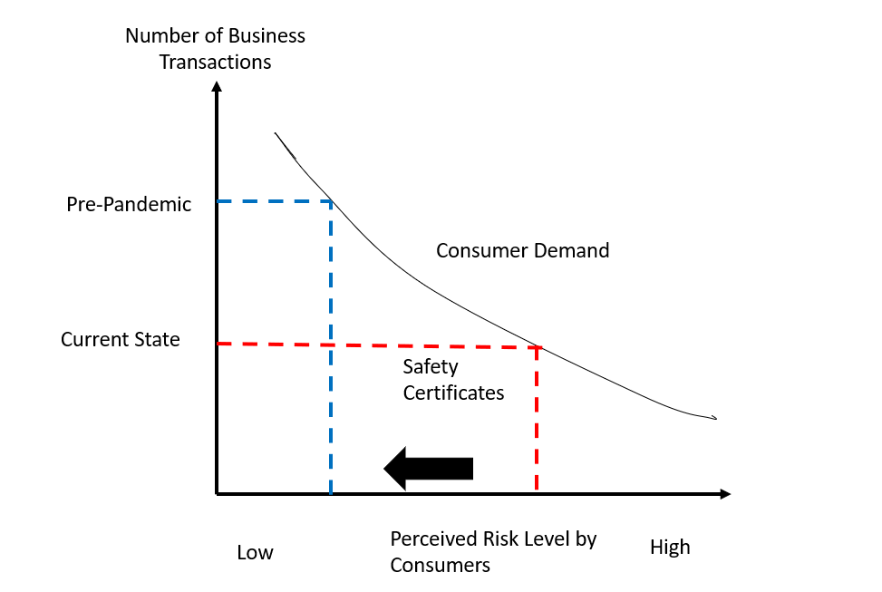

The webinar also presents a lookahead view beyond the current situation. Panel members present a vision of the emerging *paradigm shift* where safety science, economics and data-driven decision making converge to create a “new normal” for policy makers, businesses, and residents. The panel discusses the steps that can be taken at the local level to meet these coming challenges and opportunities. During the webinar panel members discuss how businesses will use safety certifications as a means of securing competitive advantage in their local geographic markets to meet the heightened demand of consumers for safety assurances.

In summary the webinar describes an integrated methodology and set of resources highlighting the importance of project management tools and methods, data sharing platforms, statistical validation, and testing/inspection/certification services for businesses. These resources are available to local communities in whole or in part to help secure immediate safety, re-establish consumer confidence and sustain long-term economic prosperity.

**References:**

Aaron, J., Bratta, C, Smith, D. (1993). Achieving Total Project Quality Control Using the Quality Gate Method. *Proceedings from PMI 1993 Annual Symposium.*

Builder, Carl H., Bankes, Steven C., Nordin, Richard. ***“****Command Concepts A Theory Derived from the Practice of Command and Control”.* Monograph Reports, Rand Corporation. 1999.

*Hayek, Friedrich (September 1945). "The Use of Knowledge in Society". The American Economic Review.* ***35*** *(4): 519–530.*

*Kuhn, Thomas S. The Structure of Scientific Revolutions*. 3rd ed. Chicago, IL: University of Chicago Press, 1996.

*Popper, Karl The Logic of Scientific Discovery. Abingdon-on-Thames: Routledge.* 1959.

*Preston, S. H (1975). "The Changing Relation between Mortality and Level of Economic Development". Population Studies.* ***29*** *(2): 231–248.*